EDA Report on Sales Dataset
  - By Azeh C. A. June 20, 2025

Introduction
The objective of this exploratory data analysis is to explore and understand sales performance across the various dimensions of the dataset and to generate useful insights.
The dataset, “sample_sales_data”, represents sales data, where every single row represents a product purchased within an order. The most important columns are the Sales, QuantityOrdered and the OrderDate columns. And there’s supplementary information on the order, customer, product and location. The data spans from 2003 to May 2005.

Data Cleaning Summary
- No error resolved.
- Attributed the appropriate datatype to each column.
- Deleted Phone, Addresslines, PostalCode, Territory and Contact names columns.
- Add PriceDifference% column; (PriceEach-MSRP/MRSP).

Exploratory Analysis

- The total sales value and orders made for all records are $10,030K and 99K, respectively.
- Sales peak in Q4 each year, with a drop in Q1. The overall trend of sales shows an upward direction (See Figure 1).
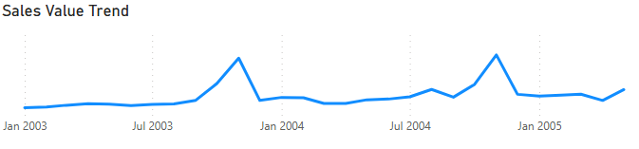
Figure 1; Sales Trend
- The amount of order made for the products closely mirror the overall sales trend, especially the top 3 products (Check out Figure 2).
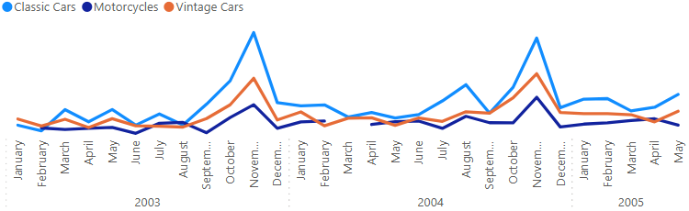
Figure 2; Top Products Order Trend
- The average monthly sales for 2003, 2004 and 2005 are $293.08K, $393.68K and $358.3K, respectively. It is important to note that, even with only five months of records in 2005 and the peak quarter excluded, its monthly sales average is about 35,000 short of the previous year's average, indicating a continuation of the increasing total yearly sales.
- Top 3 both by sales and ordered amount are Euro Shopping Channel, Mini Gifts Distribution Ltd., and Australian Collectors Co. 21.31% of sales is brought in by the top 5 customers (See Figure 3).
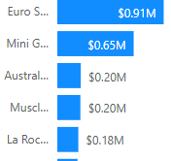
Figure 3: The top five customer and their sales value.
- Classic Cars, Vintage Cars & Motorcycles are the leading products, making up 67.35% of the total orders made (See Figure 4).
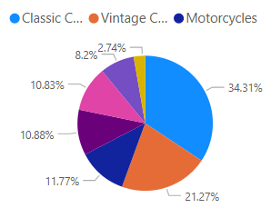
Figure 4: Product Distribution by Order
- The top countries in terms of overall sales value are the USA, Spain and France. These countries account for 59.35% of sales, with the USA alone accounting for 36.16% (Check out Figure 5).
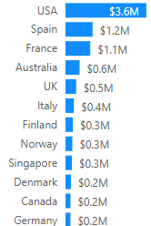
Figure 5; Country Contribution in Sales
- 92.26% of all orders have been shipped as against 1.9 % on hold between 2004 and 2005. 0.6% of the orders are disputed, with 1.68% being resolved, but 2,08% of the orders were cancelled (See Figure 6).
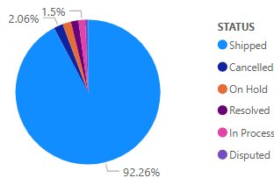
Figure 6; Distribution of Total Orders Made by Status
- Larger deals consistently attract deeper discounts, with average discounts rising from 5.79% on small deals to 28.27% on large ones (Check out Figure 7).
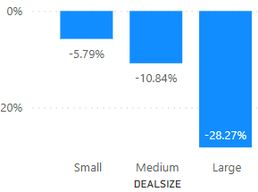
Figure 7; Average Discount on Deal Size

Conclusion and Recommendation
Summary
Sales show a consistent upward trend from 2003 to 2005, with clear seasonal peaks in Q4 and dips in Q1. Average monthly sales increased year over year, with 2005 maintaining strong performance despite only five months of data.
The top 5 out of 92 customers account for over 21% of total sales, suggesting moderate customer concentration. Product demand is heavily focused, with Classic Cars, Vintage Cars, and Motorcycles representing over 67% of all orders. The USA, Spain, and France together drive nearly 60% of total sales, with the USA alone contributing 36%.
Operational performance is strong, with 92% of orders shipped and low dispute or cancellation rates. Pricing behaviour shows that larger deals receive deeper discounts, averaging 28%, compared to 10.8% for medium and 5.8% for small deals, indicating a volume-based discount strategy. A high average discount on large deals might reduce margins.
Recommendations & Suggestions for Further Analysis
- Review discount levels on large deals to protect margins.
- Prioritize retention strategies for top customers.
- Perform profitability analysis, which would require an invoice or cost data.
- Run cohort analysis on customer order frequency or lifetime value.
- Predict future sales

